**Cancelling Quotations**

Search for the service call then select service segments

Select the segment > related info > call quotations

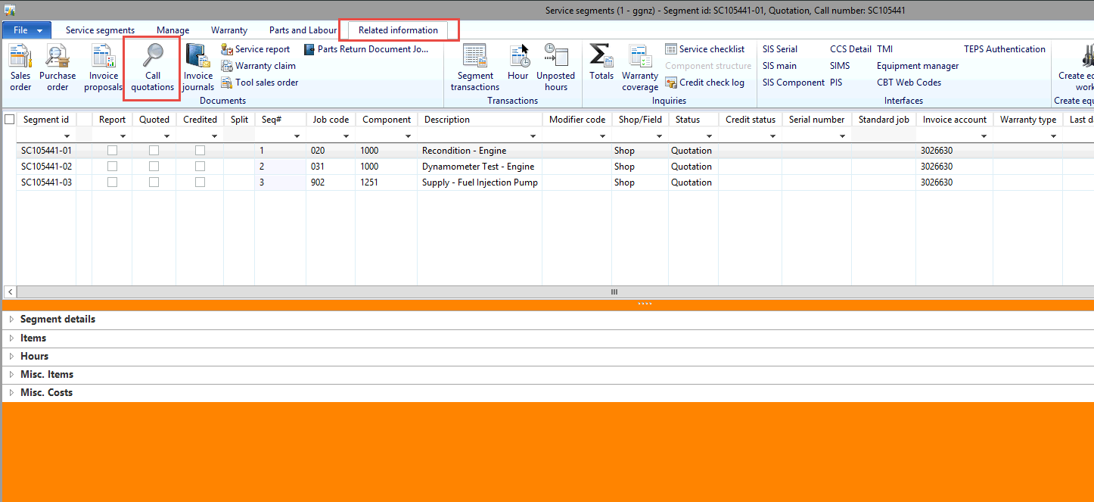

Select the quotation that says “**created”** > cancel quotation

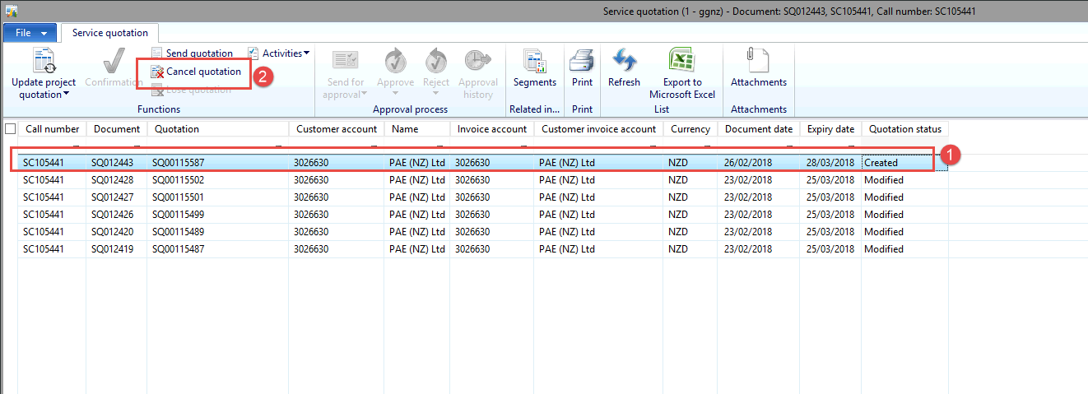

Put in the reason of **“INVALID”** > OK

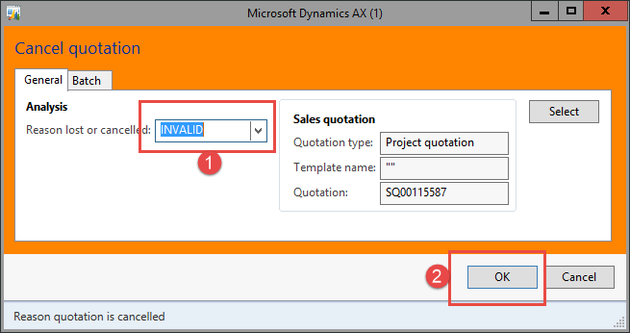

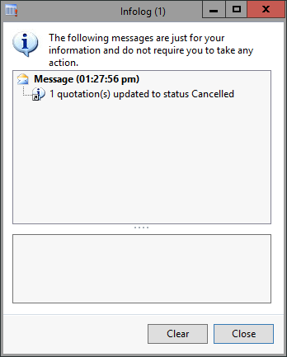

Close the quotation window and go back to the service segments

Expand “**Items**” > select all lines > select remove

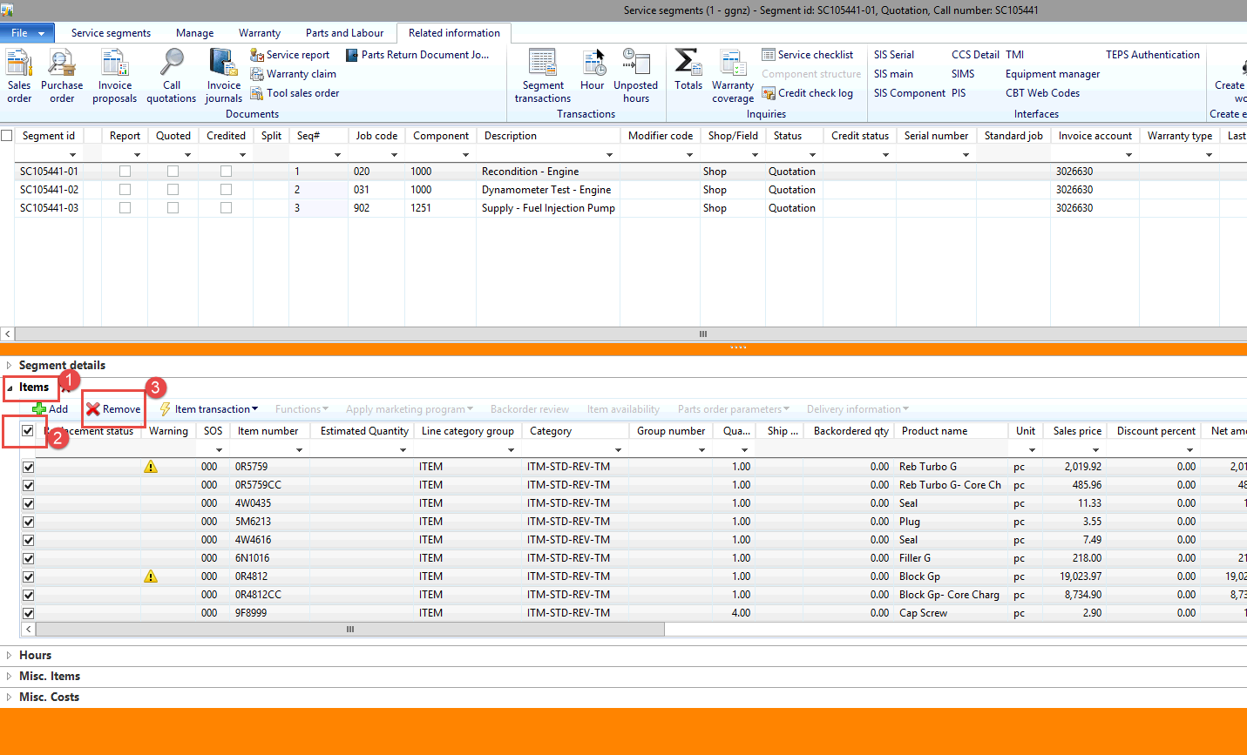

Expand **“Hours”** > select all > select remove

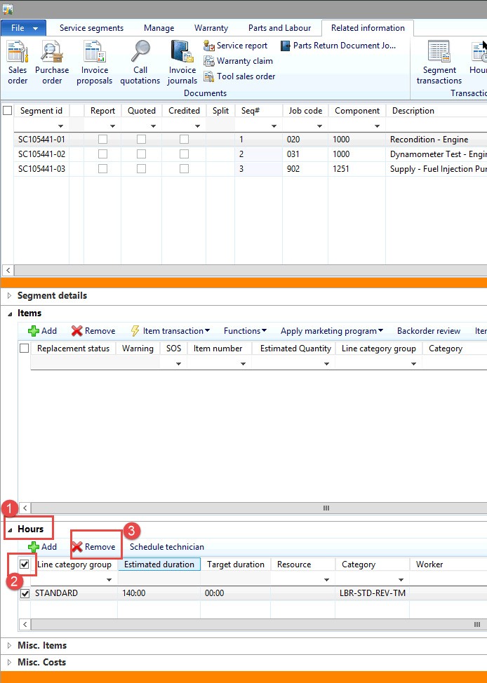

Expand **“Misc Items”** > select all > select remove

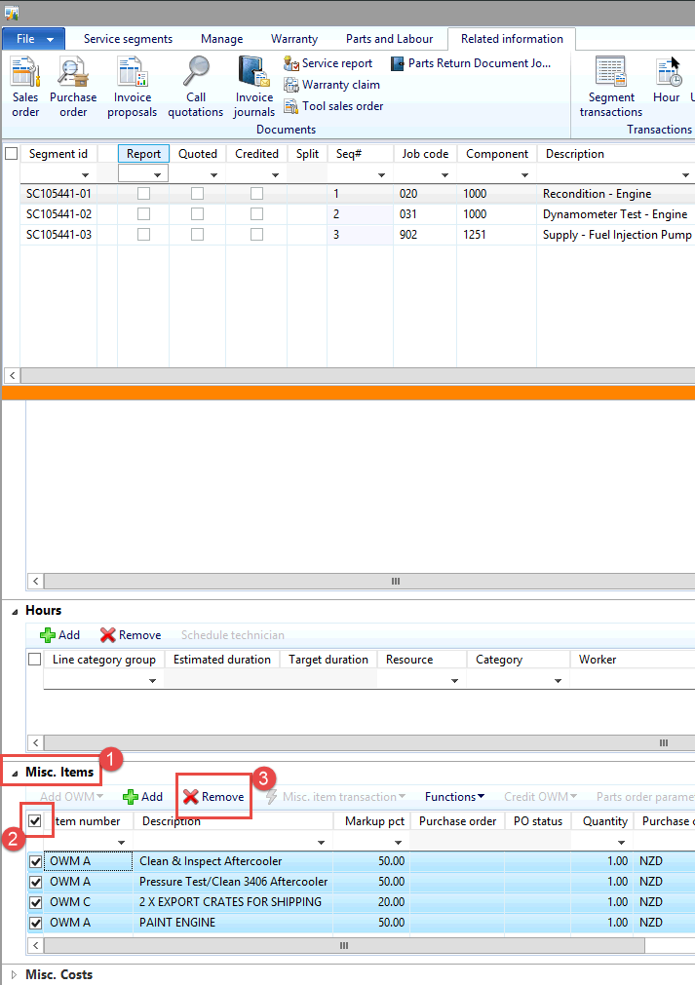

Expand **“Misc Costs”** > select all > select remove

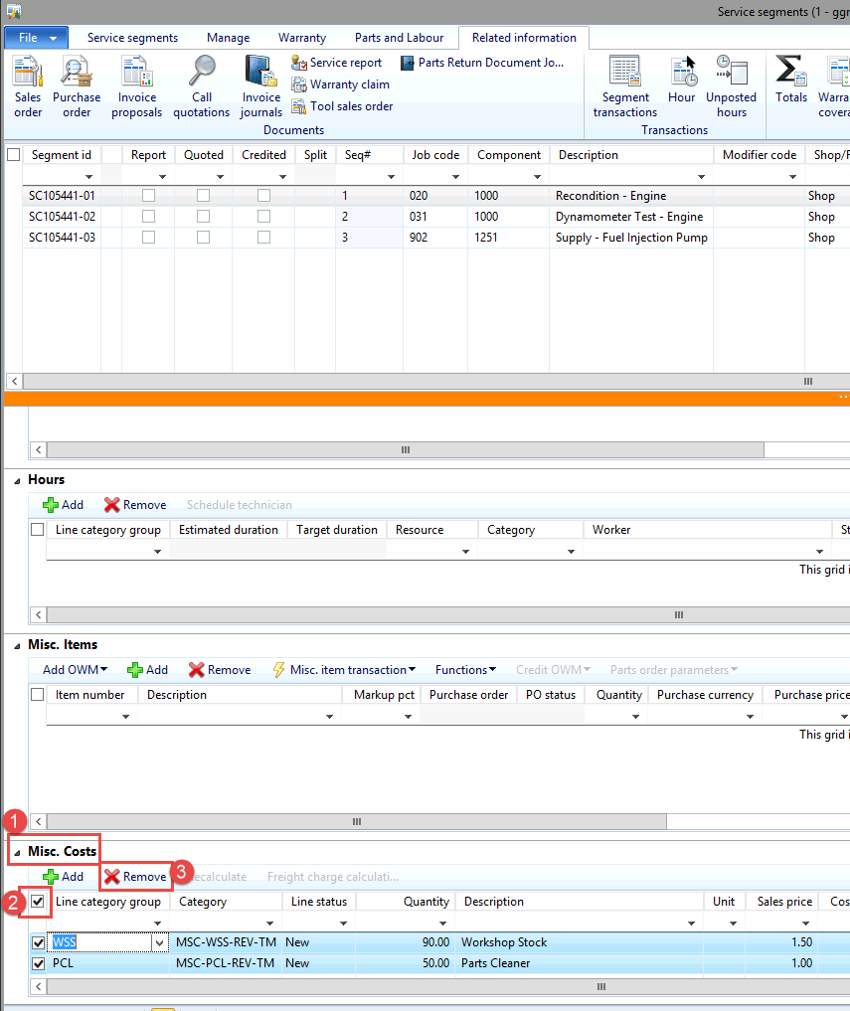

Go to the service segments tab > cancel segment

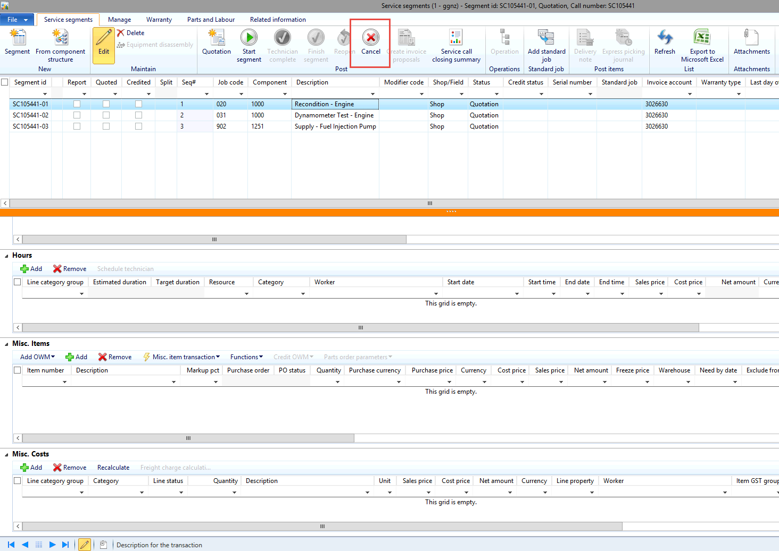

Repeat the above steps for EACH segment on EACH service call